

**FACULTY OF ENGINEERING**

ECE3186

EMBEDDED IOT SYSTEMS & APPLICATIONS

TRIMESTER 2 (2019/2020)

**IOT based Indoor Precision Farming System**

**GROUP MEMBERS:**

|  |  |  |
| --- | --- | --- |
| **Student Name** | **ID** | **Major** |
| Chiew Chin Hang | 1151102543 | CE |
| Eng Chear Shen | 1151101472 | CE |
| Tong Tian Qian | 1151102567 | CE |
| Teoh Yi Han | 1151102377 | CE |

**INTRODUCTION**

The world’s population is expected to hit 11 billion people by 2100, but land is scarce and farm yields flatlining. Undeniably, the food crisis will become an issue in the future. In order to handle this upcoming crisis, researchers are finding ways to increase the productivity of plants. This is because more than 50% of human calories are actually consumed from plants, thus, with the increment of plant productivity and growing efficiency, the crisis might be overcome.

As far as we know, traditional agriculture is easily affected by external environment factors such as humidity and temperature. An optimum surrounding condition will greatly enhance the growth of plants. However, to guarantee a suitable surrounding requires much time and huge efforts from the farmers or plantation owners as they need to be at the field to evaluate and check the plant status frequently.

Besides, traditional agriculture always causes wastage of resources because no regular feedback of the plant status. The resources such as water and land are getting more and more limited. Moreover, the increase of human population also leads to a lack of land resources for farming and decreasing of air quality in urban areas. In urban areas, people are usually busy with work and have no time to manage their plants which cause people to choose not to grow plants.

**OBJECTIVES**

To solve the problem mentioned, a solution has been proposed which will fulfill the following objectives:

1. To develop an IoT System which is capable of creating a sustainable environment that allows every citizen to plant their own plants.
2. To develop an IoT System which is capable of controlling the growth surrounding the plant.

**METHODOLOGY**

**System Architecture**

The proposed solution is a low cost IoT solution for a precision indoor farming system that allows the user to monitor the sensors data and control the actuators. The project used 2 microcontroller systems which are NodeMCU and Arduino Uno. When the sensors mounted with Arduino Uno collected the data, it will display the sensor data on LCD screen and send the data to cloud through NodeMCU and present on the IOT dashboard. When users want to control the system, the command will be sent from the IOT platform and the NodeMCU will then control the actuators and LED.

With such a system, users are able to monitor the sensors data and secure the plant growth environment even without being in the event. This should increase the plant productivity and efficiency. Also, this allows everyone in the urban area to have the ability to plant their own plants without taking much space thus creating a sustainable environment.

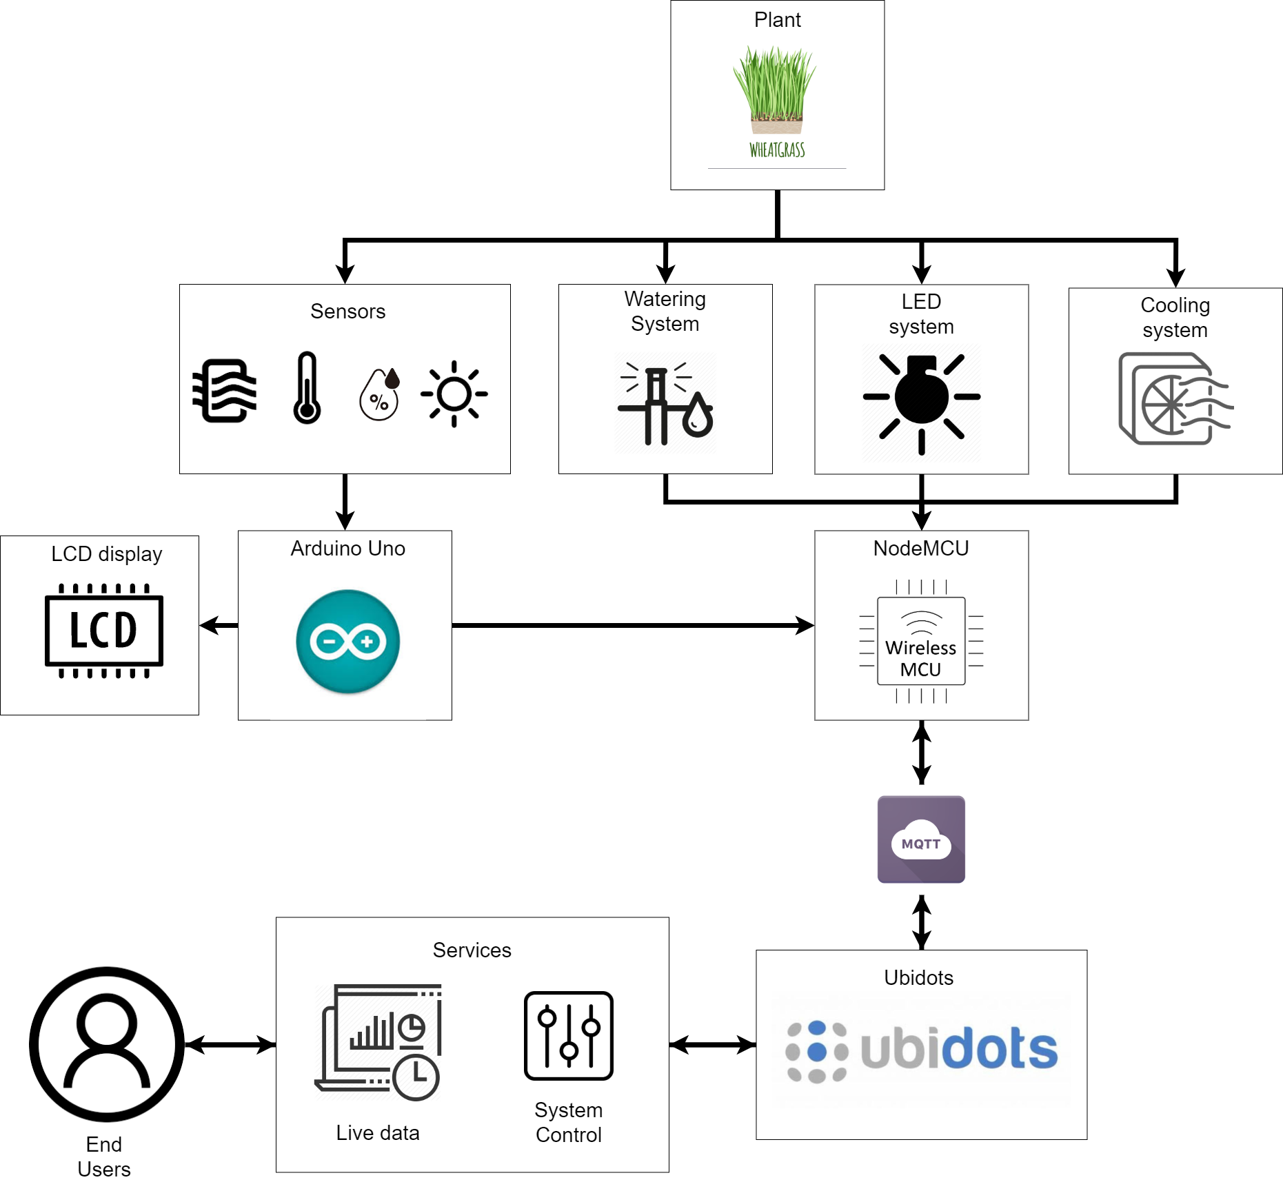

**Data flow**

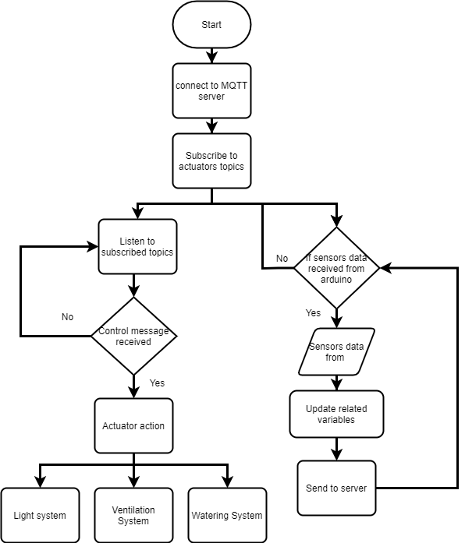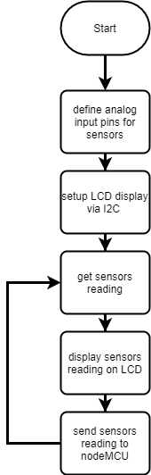

On the left side of the figure shows the data flowing arduino uno. Firstly, the analog pins for the sensors will be define and the LCD display is being setup via I2C. After that, arduino will start to get sensors reading. The sensors reading gained will be displayed on LCD as well as sending it to the nodeMCU. The flow of getting sensor reading, display and sending will keep repeating as long as arduino is power on.

On the right side of the figure shows the flowchart of nodeMCU. When the nodeMCU is powered up, it will connect to the MQTT server. Then, it will subscribe to the actuator topics. After subscribing, it can carry out 2 actions. One is receiving controls from the subscribed topic and another one is receiving sensor data from the arduino. While listening to the subscribed topic, if instruction regarding relative is received, it will carry out the actions in the instruction. However, if no instruction is received, the listening of topics will continue. On the other hand, nodeMCU will also check if sensor data is received from the arduino. When there is sensor data received, related variables will be updated and the information is sent to the Ubidots.

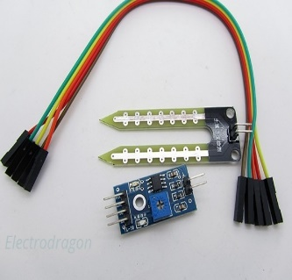**Sensors**

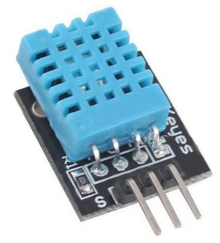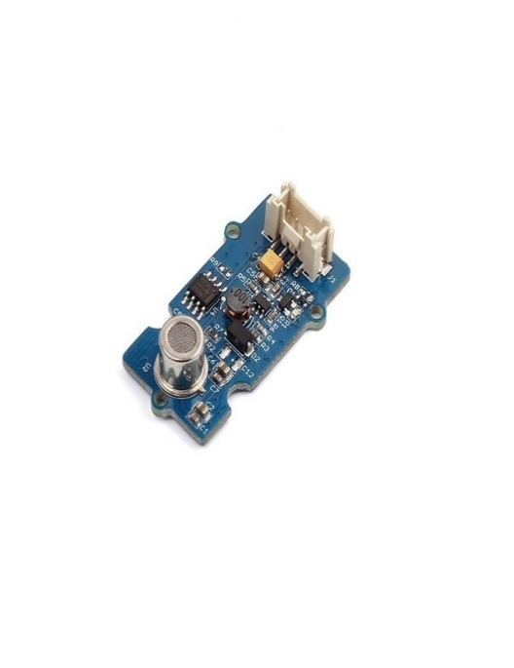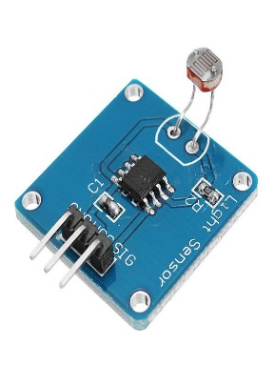

In a growth cycle of a plant, environmental factors such as temperature, air quality, humidity and moisture are decisive factors of the plant’s growth rate. Nevertheless, these factors contribute heavily to a healthy plant growth and also the productivity of the plant. Therefore, it is important to have full information regarding these factors for 24/7. To do this, sensors are needed to collect information before controlling it.

The information collected from the sensors are important for the system to take relative action toward the changes. It is also important for some growth prediction and plant health analytics. To sense the temperature and humidity, a DHT sensor will be used. For the moisture of the soil, a soil moisture sensor will be inserted into the soil. And for the light intensity, a light intensity sensor will be mounted at the growth area to measure the light intensity received by the plant. As for the air quality sensor, it is mounted in the growth area to measure the concentration of carbon dioxide in the area. All the sensors are connected directly to the Arduino Uno.

**Lighting System**

The lighting system provides the primary food source for the plant. According to reliable resources, plants require different light spectrum during different growth stages. Colour of the light has a measurable impact on the amount of energy a plant absorbs. The reason for this is the colours in light have different wavelengths and those wavelengths, depending on whether they are short or long, provide different levels of energy. Different colour light helps plants achieve different goals as well. Blue light, for example, helps encourage vegetative leaf growth. Red light, when combined with blue, allows plants to flower. Cool fluorescent light is great for cultivating plant growth indoors. Knowing that different colours of light can affect what a plant does is important in a world that depends on plants for food. Advanced LED technology is now making it possible to control the kinds of coloured light provided to the plants in controlled environments.

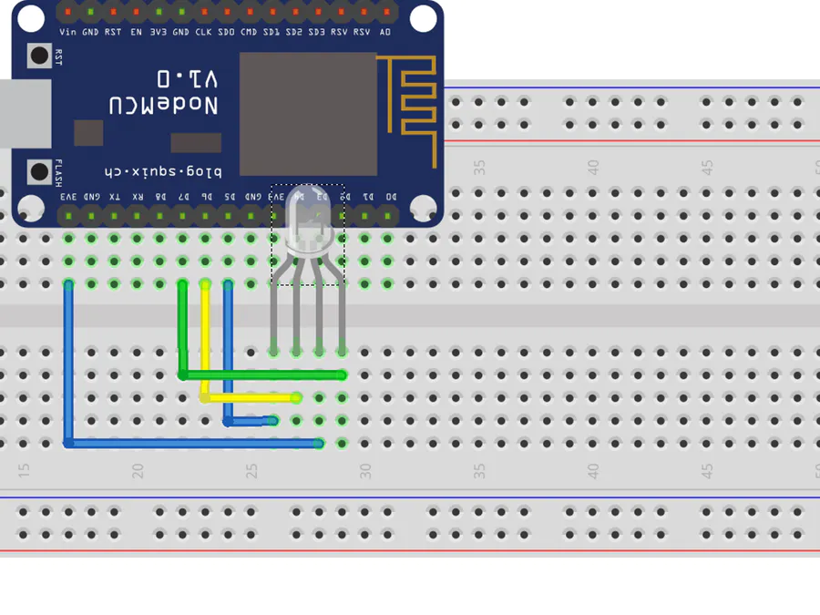

In order to provide relative light spectrum for the plant in its different growth stage, it’s important to have a controllable LED light for the system. The controllable LED light will be connected to a nodeMCU. The LED light that will be used is a common cathode LED. It has a 5V input pin and 3 pins for R, G, B channel. To control the LED, the microcontroller just needs to output from 0-5V by controlling the PWM (0-255) of the signal to each channel in order to gain different color spectrum. For example, to get white, signals pins need to send 255,255,255 to R, G, B channel.

**Watering System**

Besides light, water is also one of the crucial food sources for the plants. In the proposed solution, the watering system provides constant water supply to the plant.

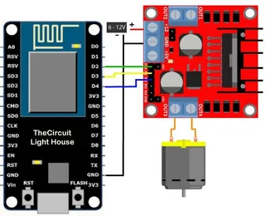

To pump the water from the source container to the plant, a water pump motor will be used. The motor needs 12v to power up. To control the motor, a L298 motor driver which is connected to the nodeMCU will be used. The motor driver is connected to 2 signal pins which control the speed watering the plant based on the signal output by the signal pins.

**Cooling System**

For some of the plants, they are very sensitive to the temperature and humidity of the environment. This part of the system is mainly used to control the air ventilation of the system. This system is designed to have a fan that will help in controlling the temperature and humidity surrounding the plant. A reliable cooling system is very important especially for the plant that needs low temperature and high humidity. The fan is connected to the nodeMCU. To turn on the fan, the hardware configuration is the same as the watering system, the 12v ventilation fan is powered by the L298 motor driver and turned on/off by the microcontroller, nodeMCU in this case.

**Results and Discussion**

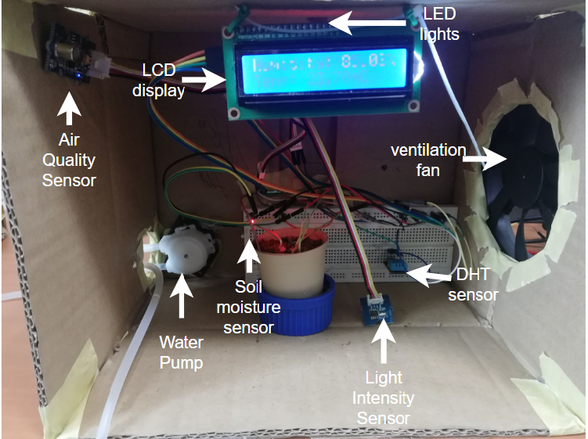

Figure above shows the system developed in this assignment. The proposed sensors and actuators have been successfully implemented. These actuators can be controlled by the user through the Ubidots platform while the sensor data can be displayed to the user through the Ubidots platform as well.

The sensor data gathered by the sensors are sent and displayed on the Ubidots platform. Each of the sensor data will tell the user the environment conditions of the plant is growing in. The DHT sensor in the system gathered the temperature and humidity of the plant surrounding. The soil moisture sensor will tell the moisture level of the soil indicating if the plant is getting water or not. Air quality sensor will tell the user the concentration of carbon dioxide in the system. Lastly the light intensity sensor will indicate if the plant is getting enough light or not. When users know the information from the sensors, actions to manipulate the growing conditions can be taken as well.

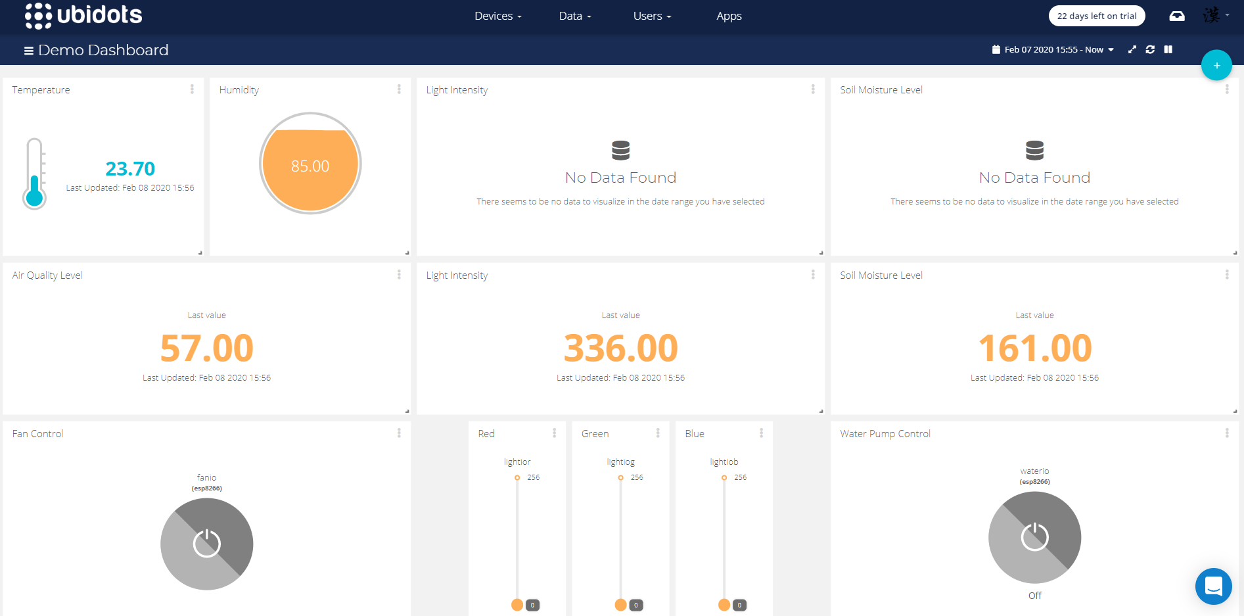

Whenever users want to make changes or take control over the system, they can do it through the Ubidots platform. To turn on the fan, by simply pressing the on off button under FanIO session in the Ubidots platform, the fan of the system can be turned on or off. With the availability of ventilation fan, the temperature and humidity of the growing area can be manipulated. In the situation where light intensity sensors indicate the grow area is dark. LED light can be turned on through Ubidots platform. Besides, the color spectrum of the LED light supplied to the plant also can be manipulated by changing the intensity level for the Red, Green, Blue channel. For different combinations of color intensity levels given, the plant can receive different colors of light from the system in different growth phases. Also, the watering actions can be carried out through the Ubidots platform if the soil moisture level is ratherly low. By turning the water pump on or off, the water from the source container can be flow to the growing area of the plant.

**Teoh Yi Han’s Contribution**

In this project, I'm in charge of all sensor components to enhance plant growth. This project uses sensor modules such as temperature & humidity sensors, water sensors, light sensors, and air quality sensors. All the sensors are designed to fit in with this project and serve full responsibility to take care of the growth plant and provide a good agricultural environment.

All sensors are used as input components for Arduino, and Arduino will then transfer data information from the sensor to NodeMCU. Starting this project, I need to identify and figure out how to connect all of these four sensor components together to the Arduino. First, the temperature and humidity sensors are connected to the Arduino digital port. Thus, whenever there is any change in temperature or humidity in the box, the sensor sends an analog signal to the Arduino and then uses the function code' Serial.print' to send the information to the NodeMCU. In addition, the temperature value can be either degree Celsius or Fahrenheit.

In conjunction, water sensors, light sensors and air quality sensors are connected to the analog port in Arduino. For these three sensors, their input signals are different as they send analog signals to Arduino while the temperature and humidity sensors send digital signals. In order to read an analog signal, the feature call 'analogRead' is used to translate an analog signal to a digital signal because the Arduino boards provide a multi-channel, 10-bit analog to a digital converter. After converting all the analog signals from the input sensor, Arduino uses the 'Serial.print' function to send all the data to NodeMCU.

In conclusion all of this is my involvement in this project where we as a team support each other and motivate each other whenever we encounter problems. During this project, I learned about different types of sensors and used them for this project. Not only that, I also learn how to read analog signal data using analogRead() the data will be converted from analog signal to digital signal. Embedded system provides a great deal of benefits to our lives and is capable of covering a wide variety of environments. Embedded technology simplified hardware, which reduces overall costs and also improves performance.

**Tong Tian Qian’s Contribution**

In this project, I am in charge of LCD display and data transmission between nodeMCU and arduino Uno. Arduino Uno is used to collect the sensors data and send to the nodeMCU and nodeMCU will push the data to the IOT platform. Before sending sensor data to the nodeMCU, it will display the sensor data on a LCD display. The LCD display requires 10 pins to function which is too much for the arduino uno. Therefore, I decided to use an I2C module for the LCD display. By using this i2c module, it only requires 4 pins which are Vcc, Gnd, SDA, and SCL from the arduino.

For the software part, I will first need to import LCD library to the program. Then, to start the I2C communication, I need to assign an address of LCD interface and begin the transmission by calling the function Wire.begin(address). When the i2c communication is started, the program will display all the sensor data with an interval of 1 second.

To push the data to the IOT platform, I need to send the sensor data from arduino uno to nodeMCU. The communication between arduino uno and nodeMCU is through serial UART. The connection can be established easily by connecting the RX and TX of arduino to TX and RX of the nodeMCU. After the setup for serial connection, arduino uno can send the sensor data using Serial.print function.

On the nodeMCU side, the data received in series of character bytes. Therefore, I have to create a function to separate data into the related variables. This is done by inserting a separator between each of the sensor data sent from the arduino uno. Whenever a separator is received, the characters received earlier will be converted to string and stored as the related variables.

To conclude, these are my contributions to this project. Throughout the project, I learnt 2 main communication protocols for microcontrollers which are I2C and serial UART. I2C is very useful and only requires 4 pins to communicate which reduces the pins usage for the project. As for UART, it only requires 2 pins to communicate. However, the data via UART needs to be reorganized to get the value we want.

**Chiew Chin Hang’s Contribution**

In this project, I am in charge of establishing the connection between nodeMCU with the IOT platform. In our case, we are using Ubidots as our IOT platform. Ubidots support MQTT protocol which is a lightweight, publish-subscribe network protocol that transports messages from the platform to the device and vice versa.

Firstly, I need to create an account on the Ubidots website and get the unique Ubidots token. This token is important to allow the nodemcu to establish connection with the Ubidots platform. After the connection is established, I need to create a new device called esp8266 and create variables for each sensor data and actuators input output. The variables include air quality, humidity, temperature, light intensity, water level, lightIO, waterIO, and fanIO.

After creating the variables, the related MQTT topics will be generated. On the other hand, nodeMCU will subscribe to the actuators input output topics such as lightIO, waterIO and fanIO to receive the command to turn on or off the actuators. For nodeMCU to send the sensor data to Ubidots platform, nodeMCU just needs to publish the sensor data together with the related topics.

To visualize the sensors data and allows users to control the actuators and LED, I created some widgets such as gauge, slider, button and graph at the dashboard of the Ubidots platform. Ubidots provides simple operation to link the widget with the variables created earlier. With all the widgets set up, users can easily access the system through the Ubidots platform.

During the process of establishing the connection, I faced a problem with the latency of messages received and sent by the Ubidots platform. After publishing a message from nodeMCU, it requires some delay before publishing the next message. This has decreased the reactivity of the whole system. However, this can be solved by switching the MQTT broker of Ubidots to a faster broker.

To conclude, these are my contributions to this project. Throughout the project, I learnt how MQTT protocol works as a publish-subscribe network protocol. Besides, I am able to understand the effectiveness and usefulness of the MQTT protocol toward IOT implementation. With IOT platforms such as Ubidots, I learnt to construct a basic embedded IoT system which allows better data visualization and provides direct access for users to control the system.

**Eng Chear Shen’s Contribution**

Throughout this project, I am in charge of the components that can manipulate the growing condition of the plants such as water pump, LED light and cooling fan. This is crucial for the system as it decides what kind of growing environment that the system is provided to the plant. Thus, affecting the growth of the plant.

The inputs that are used to control the components mentioned are received from the Ubidots platform developed. The Ubidots platform develop will give user information regarding the system as well as the control over the system. So if the user wants to make changes onto the system, a message will be sent from Ubidots to the nodeMCU of the system using MQTT. The message received by the nodeMCU contains topic and payload. Topic will specify which component that will be controlled and payload states the input to the component. Therefore, my first contribution to this assignment is to handle the messages received by nodeMCU from the Ubidots platform.

The setups of these 3 components are ratherly simple. The cooling fan and the water pump are connected to the motor driver which is connected to the nodeMCU. As for the LED light, it is connected directly to the nodeMCU. So whenever a message is received by the nodeMCU, the system will check the topic of the message whether it is the control for cooling fan, water pump or LED light. If the topic of the message is "/v1.6/devices/esp8266/fanio/lv", this means the payload of the message is the input for the fan. Therefore, nodeMCU will digitally write the input to the motor driver to control the on and off of the cooling fan. Else if the topic of the message is "/v1.6/devices/esp8266/waterio/lv”, based on the payload of the message, nodeMCU will digitally write the input to the motor drive to control the on and off of the water pump.

As for LED lights, the topic of the message are /v1.6/devices/esp8266/lightior/lv", "/v1.6/devices/esp8266/lightiog/lv" or "/v1.6/devices/esp8266/lightiob/lv" with each of it represents the color channels of RGB color space. The payloads of the message contain the intensity level of each channel set by the user. Based on the payload, nodeMCU will analogically write the input into the LED light.

These are my contributions to this assignment. Throughout this project, I have learnt how to use a nodeMCU and motor drive correctly. Besides, I am able to understand the power of embedded systems and how it improves and makes us a better life. Moreover, the power of teamwork shows its superiority as me and my team are able to finish the project on time even with only a few meetings. On the other side, it is quite a challenging assignment because of how fragile the component can be and how I have to be careful while handling the components such as motor driver. In a nutshell, it is a good and memorable experience after all.

**CONCLUSION**

The proposed solution in this assignment does actually solve the problem statement stated as it is capable of creating a sustainable environment that allows every citizen to plant their own plants at their house without committing too many spaces. Besides, this proposed solution also provides a platform for users to monitor and control the growth surrounding the plant.

However, there are certain limitations in this proposed solution. Firstly, due to the shortage of financial support, only free service from Ubidots is being used. Therefore, there is a latency when receiving sensor data or sending instructions to the system. Besides, the proposed is yet to be fully automated. This is because there is insufficient plant data collected in this short period of time. Therefore, humans are still needed to control the growth environment condition as the system does not know the optimum environment of the plant.

**WordPress link**

[http://iotfarmingsystem.design.blog/](http://iotfarmingsystem.design.blog/?fbclid=IwAR02evgsHmk7AlXkvUTnb6TAQjweHTWxYNeCN-Re6M6iTOBTGljTPmzWJhk)